**Title:**

Create and edit webpages using html,css amd javascript

**Keywords:**

Js frontend css scss html urgent

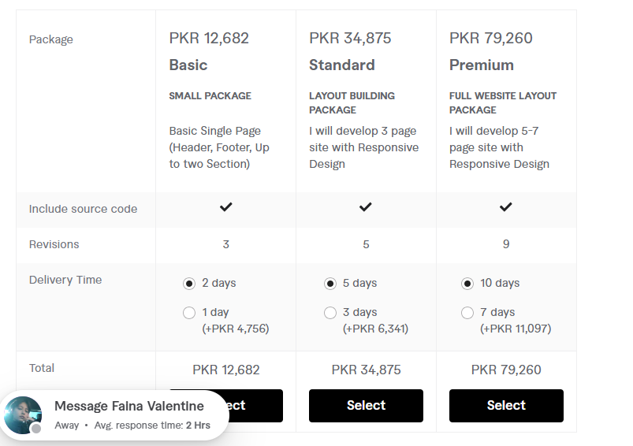

**GIG Description:**

Unresponsive or flat website? Troubles with HTML5 | CSS | JavaScript code and no developer to fix it? Do you want to rebrand or renew your site and feel completely lost when doing it?

That is where I come into play!

I will help you fix your code, create a layout from scratch and remake HTML5 pages in a reasonable time for a reasonable price.

What I can do in Layout Programming:

* HTML5 site one page
* HTML5 site with multiple pages
* CSS | SCSS site with multiple pages
* CSS | JS Animation
* Web Landing page
* Fix any HTML5 | CSS | SCSS | JS bugs
* Asses browser compatibility
* JS Programming

Tools for Programming:

* Gulp
* Web Storm
* HTML5 | CSS3 | SCSS | JS

What bugs and problems I solve:

* Responsive Website
* JavaScript Problem
* HTML5 | CSS3 | SCSS Section
* Script Rewrite
* Web page Redesign

NOTE: Please contact me before plagin your order!

NOTE: Please note that this gig includes Development work only. The Design should be provided by you. If you don't have the designs ready, send me a message directly.

Waiting for your order, regards!

**requirements**

**Please make ensure that you provide all the necessary requirements of the project/task Before placing an order**